**Daniel Johnson**

**A53072130**

**BGGN213 2019 Midterm “Find a Gene Project”**

**[Q1]Protein Name**

Protein Name: **CBFA2T1** (Product of *RUNX1T1* Gene)

Species: **Human**

Accession: **NX_Q06455**

**[Q2] Blast Search Results**

**Blast Input:**

>sp|Q06455|MTG8_HUMAN Protein **CBFA2T1** OS=**Homo sapiens** OX=9606 GN=**RUNX1T1** PE=1 SV=2

MISVKRNTWRALSLVIGDCRKKGNFEYCQDRTEKHSTMPDSPVDVKTQSRLTPPTMPPPP

TTQGAPRTSSFTPTTLTNGTSHSPTALNGAPSPPNGFSNGPSSSSSSSLANQQLPPACGA

RQLSKLKRFLTTLQQFGNDISPEIGERVRTLVLGLVNSTLTIEEFHSKLQEATNFPLRPF

VIPFLKANLPLLQRELLHCARLAKQNPAQYLAQHEQLLLDASTTSPVDSSELLLDVNENG

KRRTPDRTKENGFDREPLHSEHPSKRPCTISPGQRYSPNNGLSYQPNGLPHPTPPPPQHY

RLDDMAIAHHYRDSYRHPSHRDLRDRNRPMGLHGTRQEEMIDHRLTDREWAEEWKHLDHL

LNCIMDMVEKTRRSLTVLRRCQEADREELNYWIRRYSDAEDLKKGGGSSSSHSRQQSPVN

PDPVALDAHREFLHRPASGYVPEEIWKKAEEAVNEVKRQAMTELQKAVSEAERKAHDMIT

TERAKMERTVAEAKRQAAEDALAVINQQEDSSESCWNCGRKASETCSGCNTARYCGSFCQ

HKDWEKHHHICGQTLQAQQQGDTPAVSSSVTPNSGAGSPMDTPPAATPRSTTPGTPSTIE

TTPR

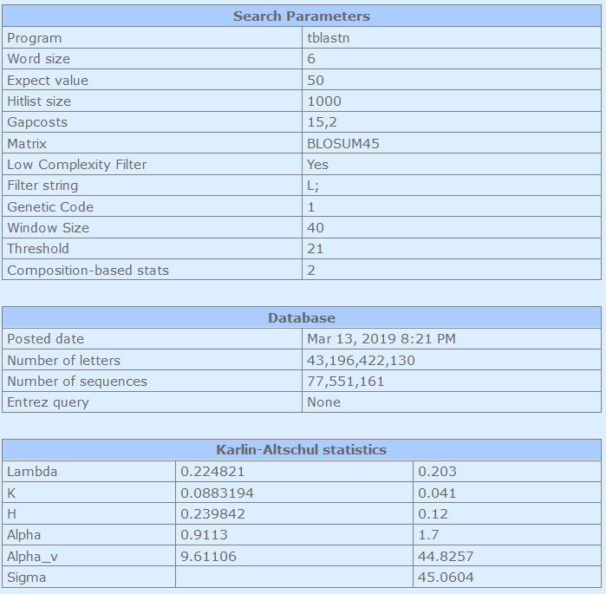

**Blast Output:**

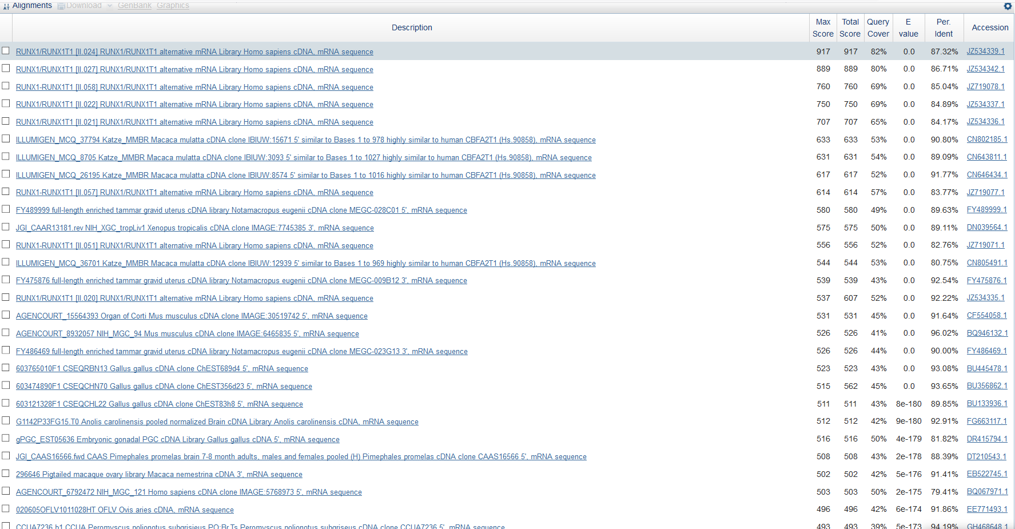

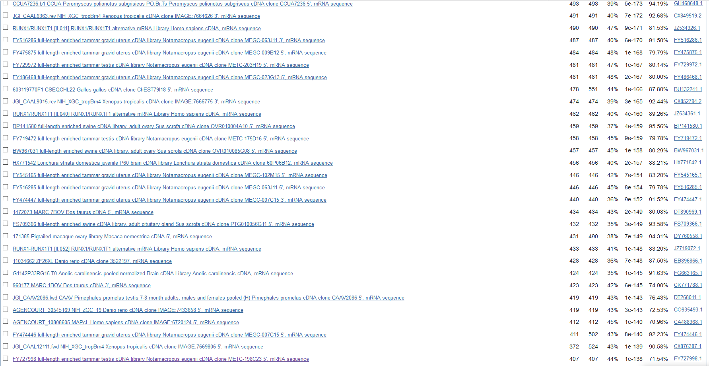

**Selected homolog:**

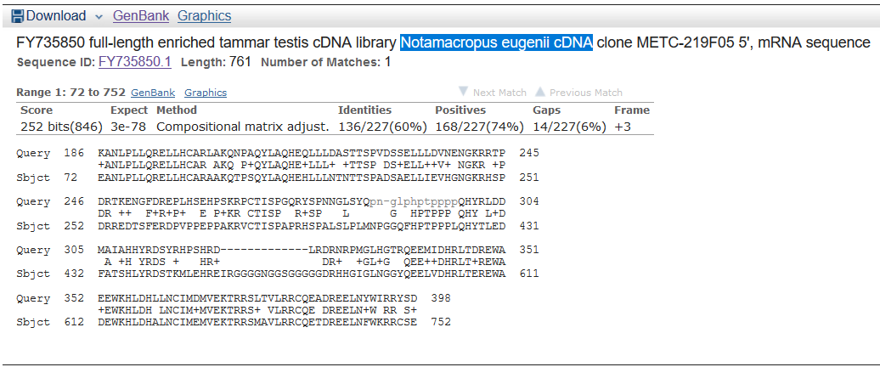

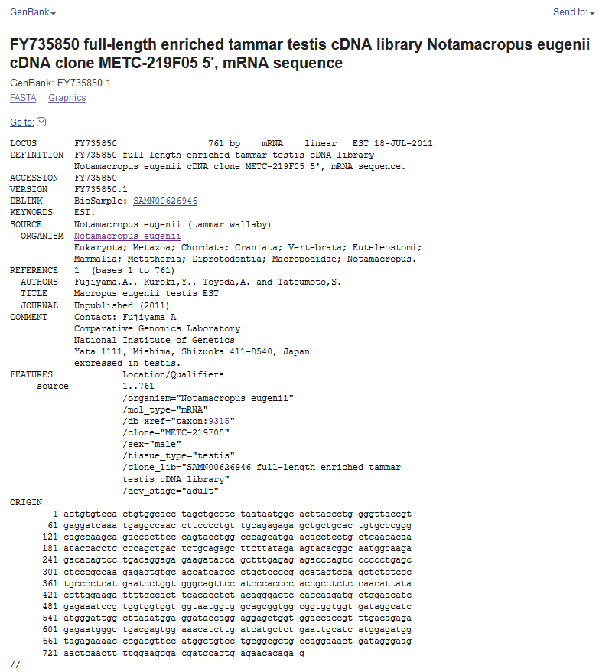

**[Q3] Novel Protein Information**

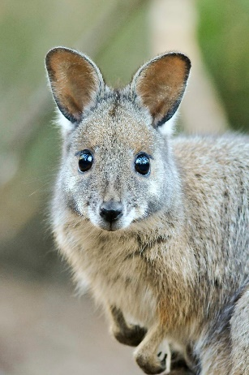Species: Notamacropus Eugenii (Tammar Wallaby)

Novel Protein Name: **CBFA2T1**

**Novel Protein Translated.**

>EMBOSS_001_Frame 1

TVSTVAPSCL**WHLPWGYREDQMRPTFPCCRESCCTVPGQPSRPLPSTWPSMNTSCSTQ

IPPPQLTLQSFL*KYTAMARDTVLTGEKIPALRETQSPLSLPPRECAPSALLPGIVQLSP

CPS*ILVGSSIPPHRLSNIIPWKILPLHTSTGTPPRCWNIEKSVVVVVMVAAVAVVVIGI

MGLA*MEDTRRSWWTTV*QRENGLTSGNILIML*IASWRW*RKPDVPWLSCGAARKLIGK

NSTFGSDDAVRTQX

>EMBOSS_001_Frame 2

LCPLWHLAASNNGTYPGVTVRIK*GQPSPVAERAAALCPGSQADPFPVPGPA*TPPAQHK

YHLPS*LCRASYRSTRQWQETQS*QERRYQL*ERPSPP*ASRQESVHHQPCSPA*SSSLP

APHESWWAVPSHPTASPTLYLGRFCHFTPLQGLHQDAGTSRNPWWWW*WWQRWRWW**AS

WDWLKWRIPGGAGGPPFDRERMG*RVETS*SCSELHHGDGRENPTFHGCPAALPGN**GR

TQLLEATMQ*EHRX

**>EMBOSS_001_Frame 3 CBFA2T1 Predicted Sequence (from EST)**

CVHCGT*LPLIMALTLGLP*GSNEANLPLLQRELLHCARAAKQTPSQYLAQHEHLLLNTN

TTSPADSAELLIEVHGNGKRHSPDRREDTSFERDPVPPEPPAKRVCTISPAPRHSPALSL

PLMNPGGQFHPTPPPLQHYTLEDFATSHLYRDSTKMLEHREIRGGGGNGGSGGGGGDRHH

GIGLNGGYQEELVDHRLTEREWADEWKHLDHALNCIMEMVEKTRRSMAVLRRCQETDREE

LNFWKRRCSENTE

>EMBOSS_001_Frame 4

LCSHCIVASKS*VLPYQFPGSAAGQPWNVGFSLPSP*CNSEHDQDVSTRQPILSLSNGGP

PAPPGILHLSQSHDAYHHHRHRCHHYHHHHGFLDVPASWWSPCRGVKWQNLPRYNVGEAV

GWDGTAHQDS*GAGRELDYAGEQG*WCTLSWREAQGGLGLSQSWYLLSCQDCVSCHCRVL

L*EALQSQLGRWYLC*AGGVHAGPGTGKGSAWLPGHSAAALSATGEGWPHLILTVTPG*V

PLLEAARCHSGHS

>EMBOSS_001_Frame 5

SVFSLHRRFQKLSSSLSVSWQRRRTAMERRVFSTISMMQFRA*SRCFHSSAHSLSVKRWS

TSSSWYPPFKPIP*CLSPPPPPLPPLPPPPRISRCSSILVESL*RCEVAKSSKV*CWRGG

GVGWNCPPGFMRGRERAGLCRGAGLMVHTLLAGGSGGTGSLSKLVSSLLSGLCLLPLPCT

SIRSSAESAGEVVFVLSRRCSCWARYWEGVCLAARAQCSSSLCNRGRLASFDPHGNPRVS

AIIRGS*VPQWTQX

>EMBOSS_001_Frame 6

LCVLTASSLPKVEFFPISFLAAPQDSHGTSGFLYHLHDAIQSMIKMFPLVSPFSLCQTVV

HQLLLVSSI*ANPMMPITTTATAATITTTTTDFSMFQHLGGVPVEV*SGKIFQGIMLERR

WGGMELPTRIHEGQGESWTMPGSRADGAHSLGGRLRGDWVSLKAGIFSPVRTVSLAIAVY

FYKKLCRVSWGGGICVEQEVFMLGQVLGRGLLGCPGTVQQLSLQQGKVGLI*SSR*PQGK

CHY*RQLGATVDTV

**[Q4]Proof of Novelty**

**>EMBOSS_001_Frame 3 CBFA2T1 Predicted Sequence (from EST)**

GSNEANLPLLQRELLHCARAAKQTPSQYLAQHEHLLLNTNTTSPADSAELLIEVHGNGKR

HSPDRREDTSFERDPVPPEPPAKRVCTISPAPRHSPALSLPLMNPGGQFHPTPPPLQHYT

LEDFATSHLYRDSTKMLEHREIRGGGGNGGSGGGGGDRHHGIGLNGGYQEELVDHRLTER

EWADEWKHLDHALNCIMEMVEKTRRSMAVLRRCQETDREELNFWKRRCSENTE

